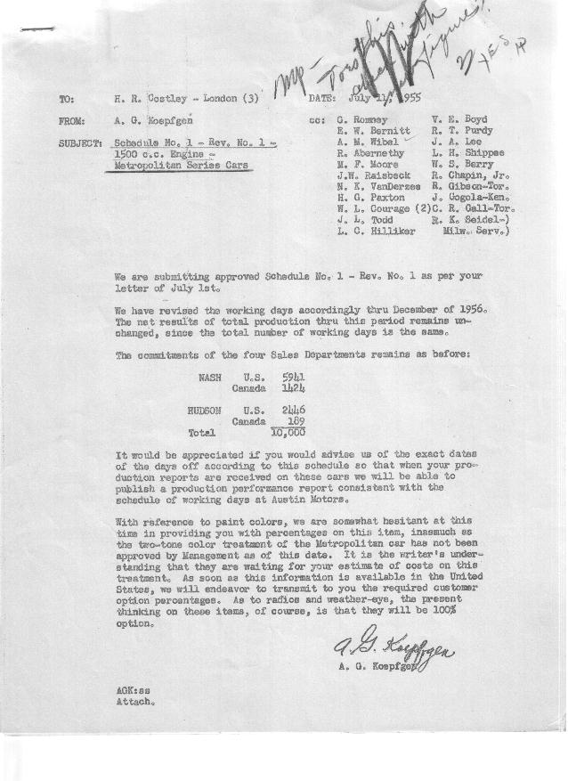

FORM PLAN 68 REV. 2-55-A.M.P Sheet No. 1 of 2 APPROVED W.L. Courage & E.W. Bernitt(signed) DATE 7-7-55 & 7-11-55

SCHEDULE NO. ______1 ________ DATE May 27, 1955 MONTHLY BUILDING SCHEDULE APPROVED J.W. Raisbeck (signed)_ DATE_ 7-8-55 ____ REVISION NO. _______1 _______ DATE July 6, 1955 PRODUCT APPROVED_R.T. Purdy (signed) ___________DATE 7-11-55 ____
1500 c.c. Engine Model
METROPOLITAN SERIES CARS – AUSTIN MOTORS C. LTD., ENGLAND
DESCRIPTION | BUILT  ACT◻ EST  THRU  12-31-55 | FIRM BUILDING SCHEDULE  (FABRICATED MATERIAL RELEASE) |  |  |  |  |  |  |  |  |  |  |  |  |  |  | TENTATIVE SCHEDULE  (RAW MATERIAL RELEASED) |  |  | GRAND  TOTAL
DESCRIPTION | BUILT  ACT◻ EST  THRU  12-31-55 | MONTH JANUARY, 1956  DAYS 22 |  |  | MONTH FEBRUARY  DAYS 21 |  |  | MONTH MARCH  DAYS 22 |  |  | MONTH APRIL  DAYS 19 (1) |  |  | MONTH MAY  DAYS 21 |  |  | MONTH JUNE  DAYS 21 |  |  | GRAND  TOTAL
DESCRIPTION | BUILT  ACT◻ EST  THRU  12-31-55 | DAILY | MONTH | CUM’L  TOTAL | DAILY | MONTH | CUM’L  TOTAL | DAILY | MONTH | CUM’L  TOTAL | DAILY | MONTH | CUM’L  TOTAL | DAILY | MONTH | CUM’L  TOTAL | DAILY | MONTH | CUM’L TOTAL | GRAND  TOTAL
NASH
Hard-Top Conv. | 0 |  | 564 | 564 |  | 512 | 1076 |  | 479 | 1555 |  | 380 | 1935 |  | 420 | 2355 |  | 422 | 2777
Soft-Top Conv. | 0 |  | 0 | 0 |  | 60 | 60 |  | 125 | 185 |  | 112 | 297 |  | 112 | 409 |  | 60 | 469
Total | 0 |  | 564 | 564 |  | 572 | 1136 |  | 604 | 1740 |  | 492 | 2232 |  | 532 | 2764 |  | 482 | 3246
HUDSON
Hard-Top Conv. | 0 |  | 133 | 133 |  | 85 | 218 |  | 85 | 303 |  | 99 | 402 |  | 119 | 521 |  | 161 | 682
Soft-Top Conv. | 0 |  | 7 | 7 |  | 15 | 22 |  | 15 | 37 |  | 17 | 54 |  | 21 | 75 |  | 29 | 104
Total | 0 |  | 140 | 140 |  | 100 | 240 |  | 100 | 340 |  | 116 | 456 |  | 140 | 596 |  | 190 | 786
CORPORATION TOTAL
Hard-Top Conv. | 0 |  | 697 | 697 |  | 597 | 1294 |  | 564 | 1858 |  | 479 | 2337 |  | 539 | 2876 |  | 583 | 3459
Soft-Top Conv. | 0 |  | 7 | 7 |  | 75 | 82 |  | 140 | 222 |  | 129 | 351 |  | 133 | 484 |  | 89 | 573
Total | 0 |  | 704 | 704 |  | 672 | 1376 |  | 704 | 2080 |  | 608 | 2688 |  | 672 | 3360 |  | 672 | 4032
 |  | Month JULY 1956  Days 20 (2) |  |  | Month AUGUST  Days 15 (3) |  |  | Month SEPTEMBER  Days 20 |  |  | Month OCTOBER  Days 23 |  |  | Month NOVEMBER  Days 22 |  |  | Month DECEMBER  Days 18 (4)
NASH
Hard-Top Conv. |  |  | 495 | 3272 |  | 342 | 3614 |  | 470 | 4084 |  | 516 | 4600 |  | 496 | 5096 |  | 415 | 5511
Soft-Top Conv. |  |  | 15 | 484 |  | 8 | 492 |  | 0 | 492 |  | 0 | 492 |  | 0 | 492 |  | 0 | 492
Total |  |  | 510 | 3756 |  | 350 | 4106 |  | 470 | 4576 |  | 516 | 5092 |  | 496 | 5588 |  | 415 | 6003
HUDSON
Hard-Top Conv. |  |  | 110 | 792 |  | 110 | 902 |  | 170 | 1072 |  | 220 | 1292 |  | 208 | 1500 |  | 161 | 1661
Soft-Top Conv. |  |  | 20 | 124 |  | 20 | 144 |  | 0 | 144 |  | 0 | 144 |  | 0 | 144 |  | 0 | 144
Total |  |  | 130 | 916 |  | 130 | 1046 |  | 170 | 1216 |  | 220 | 1436 |  | 208 | 1644 |  | 161 | 1805
CORPORATION TOTAL
Hard-Top Conv. |  |  | 605 | 4064 |  | 452 | 4516 |  | 640 | 5156 |  | 736 | 5892 |  | 704 | 6596 |  | 576 | 7172
Soft-Top Conv. |  |  | 35 | 608 |  | 28 | 636 |  | 0 | 636 |  | 0 | 636 |  | 0 | 636 |  | 0 | 636
Total |  |  | 640 | 4672 |  | 480 | 5152 |  | 640 | 5792 |  | 736 | 6528 |  | 704 | 7232 |  | 576 | 7808
 | (1) Was 18.
 | (2) Was 15.
(3) Was 20.
(4) Was 19.

FORM PLAN 68 REV. 2-55-A.M.P Sheet No. 2 of 2 APPROVED W.L. Courage & E.W. Bernitt(signed) DATE 7-7-55 & 7-11-55

SCHEDULE NO. ______1 ________ DATE May 27, 1955 MONTHLY BUILDING SCHEDULE APPROVED J.W. Raisbeck (signed)_ DATE_ 7/8/55 ____ REVISION NO. _______1 _______ DATE July 6,1955 PRODUCT APPROVED_R.T. Purdy (signed) ___________DATE_ 7/11/55 ____
1500 c.c. Engine Model
METROPOLITAN SERIES CARS – AUSTIN MOTORS C. LTD., ENGLAND
DESCRIPTION | BUILT  ◻ACT◻ EST  THRU | FIRM BUILDING SCHEDULE  (FABRICATED MATERIAL RELEASE) |  |  |  |  |  |  |  |  |  |  |  |  |  |  | TENTATIVE SCHEDULE  (RAW MATERIAL RELEASED) |  |  | GRAND  TOTAL
DESCRIPTION | BUILT  ◻ACT◻ EST  THRU | MONTH JANUARY, 1957  DAYS 22 |  |  | MONTH FEBRUARY  DAYS 20 |  |  | MONTH MARCH  DAYS 21 |  |  | MONTH APRIL  DAYS 5.5 |  |  | MONTH  DAYS |  |  | MONTH  DAYS |  |  | GRAND  TOTAL
DESCRIPTION | BUILT  ◻ACT◻ EST  THRU | DAILY | MONTH | CUM’L  TOTAL | DAILY | MONTH | CUM’L  TOTAL | DAILY | MONTH | CUM’L  TOTAL | DAILY | MONTH | CUM’L  TOTAL | DAILY | MONTH | CUM’L  TOTAL | DAILY | MONTH | CUM’L TOTAL | GRAND  TOTAL
NASH
Hard-Top Conv. |  |  | 431 | 5942 |  | 342 | 6284 |  | 307 | 6591 |  | 67 | 6658
Soft-Top Conv. |  |  | 10 | 502 |  | 60 | 562 |  | 115 | 677 |  | 30 | 707
Total |  |  | 441 | 6444 |  | 402 | 6846 |  | 422 | 7268 |  | 97 | 7365
HUDSON
Hard-Top Conv. |  |  | 251 | 1912 |  | 194 | 2106 |  | 204 | 2310 |  | 67 | 2377
Soft-Top Conv. |  |  | 12 | 156 |  | 44 | 200 |  | 46 | 246 |  | 12 | 258
Total |  |  | 263 | 2068 |  | 238 | 2306 |  | 250 | 2556 |  | 79 | 2635
CORPORATION TOTAL
Hard-Top Conv. |  |  | 682 | 7854 |  | 536 | 8390 |  | 511 | 8901 |  | 134 | 9035
Soft-Top Conv. |  |  | 22 | 658 |  | 104 | 762 |  | 161 | 923 |  | 42 | 965
Total |  |  | 704 | 8512 |  | 640 | 9152 |  | 672 | 9824 |  | 176 | 10,000

